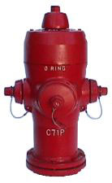
Over the next few months Sun Peaks Municipality’s Public Works’ crews will be working at fire hydrants and you may notice water running down the street. We are flushing water lines through the use of fire hydrants, which is an important preventive maintenance activity. Although it may appear to waste water, the process is part of a routine maintenance program necessary to maintain the integrity of the water system and allowing us to continue to deliver the highest quality water possible to our customers.
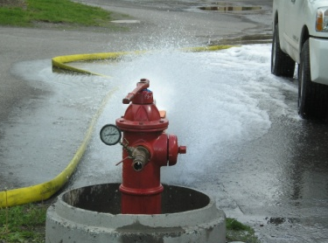
As a result of the line flushing process, residents in the immediate vicinity of the work may experience temporary discoloration of their water. This discoloration consists primarily of harmless deposited minerals (iron & manganese) and air and does not affect the safety of the water. If you experience discoloration in your water after crews have been flushing in your neighbourhood, clear the pipes in your home by running all water faucets for a few minutes.
The same philosophy of water line preventive maintenance is one that you should use in your own home to ensure the quality of water inside your home. Your home’s water heater should be drained and flushed on a regular basis according to manufacturers’ recommendations, to keep it working effectively and efficiently.
Why does the water system need to be routinely flushed? The community’s water distribution system is a complex network of pipes and water storage reservoirs where naturally deposited minerals accumulate over time. If not removed from time to time, these materials may cause taste & odour problems, or discoloration of the water. Water may also stagnate in lesser used parts of the distribution system and can result in poor water quality.
What should I do when I see crews flushing hydrants in my area? If you see the Public Works crew flushing hydrants, PLEASE SLOW DOWN, OBEY TRAFFIC SIGNS & DRIVE CAREFULLY to avoid any chance of hydroplaning. Do not cross a fire hose unless signalled by the crew that it is ok to.
What should I do after the flushing? If the tap water is used during flushing, it could come out full of sediment and discoloration that can be stirred up during flushing. If you encounter discoloured water, shut the water off and wait several minutes. After waiting, check the clarity by running cold water for a few minutes allowing new water to work its way into your pipes. If it’s still not running clear, wait a few more minutes and check again. In some cases, you may experience slight discoloration for a few hours. This discoloration only affects the appearance of the water; it does not affect the taste or water quality. If discoloration persists for more than 24 hours, please email utilities@sunpeaksmunicipality.ca with a picture and location.
What should I do if my water pressure or volume seems low after flushing? Check your faucet’s aeration screens for trapped debris.
What deposits remain in the water system after flushing? Sun Peaks’ Water comes from deep wells and a spring fed surface reservoir. The water contains naturally occurring minerals such as Iron and Manganese, which are removed at one of the four water treatment plants. This treatment using either Manganese Dioxide or Membrane Filtration removes approximately 99% of the minerals. Over time a small amount of the minerals settle out in the underground pipes and reservoirs. This process occurs on the inside of the distribution pipes and if left unaddressed, would eventually prevent an adequate volume of water flow. Annual flushing process removes these deposits.

