Notice of Hearing

WHEN: 3:00PM August 19, 2025
WHERE: Sun Peaks Centre – 3200 Valley Drive, Sun Peak, BC
WHY: Council is considering issuance of Temporary Use Permit renewals.

What is Temporary Use Permit No.TUP-2023-007R
TUP-2023-007R, if approved, would temporarily permit short term nightly rentals in the 4 bedroom principal dwelling unit at 5300 Lookout Ridge Drive, legally described as Lot 24 DL 6466 KDYD Plan KAP80085 as highlighted below for up to a 2-year term. This Property currently holds a valid temporary use permit for short-term rentals.

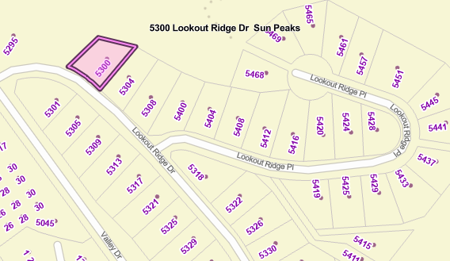

What is Temporary Use Permit No.TUP-2024-004
TUP-2024-004, if approved, would temporarily permit short term nightly rentals in the 1 bedroom auxiliary dwelling unit at 5305 Lookout Ridge Drive, legally described as legally described as Lot 2 DL 6466 KDYD Plan KAP80085 as highlighted below for up to a 2-year term. This Property currently holds a valid temporary use permit for short-term rentals.

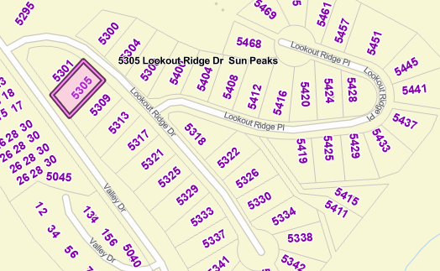

All persons who believe that their interest in property may be affected by the proposed TUP shall be afforded a reasonable opportunity to be heard at the Hearing. Additionally, they may make written submissions (via any of the below options) which must be received at our office prior to 4:00 p.m. on the13th of August. The entire content of all submissions will be made public and form a part of the public record on this matter.

A copy of the proposed Permit and all supporting information can be inspected from 8:30 a.m. to 4:00 p.m., Monday - Friday at our office until 1:00 p.m. the day of the Hearing.
No representations will be received by Council after the Hearing has been concluded.

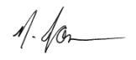

Nicky Jonsson
Director of Corporate Services

Mail or In-Person: 106-3270 Village Way, Sun Peaks, BC V0E 5N0
Email: admin@sunpeaksmunicipality.ca
Fax: 250-578-2023

