Notice of Hearing

WHEN: August 19, 2025 at 3:00PM
WHERE: Sun Peaks Centre – 3200 Valley Drive, Sun Peak, BC
WHY: Council is considering issuance of Development Variance Permit DVP-2025-001

What is Development Variance Permit No.DVP-2025-001
DVP-2025-001 if approved, would vary the required number of off-street parking stalls from 176 to 57 at 1180 Sun Peaks Road, legally described as Lot A, District Lot 5957 K.D.Y.D, Plan EPP125011 as highlighted below. An additional 65 parking stalls (for a total of 122 parking stalls for the project) would be provided by agreement on 1188 Sun Peaks Road.

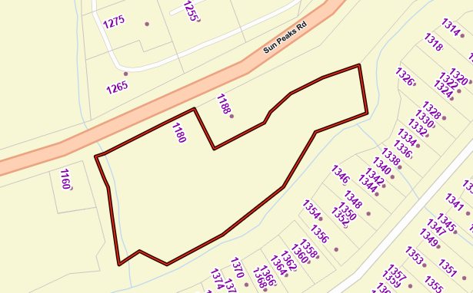

All persons who believe that their interest in property may be affected by the proposed Permit shall be afforded a reasonable opportunity to be heard at the Hearing. Additionally, they may make written submissions (via mail or email) that must be received at the Sun Peaks Municipal office located at 106-3270 Village Way prior to 4:00 p.m. on the 13th of August. The entire content of all submissions will be made public and form a part of the public record on this matter.
A copy of the proposed Permit and all supporting information can be inspected from 8:30 a.m. to 4:00 p.m., Monday - Friday at the Sun Peaks Municipal office located at 106-3270 Village Way until 1:00 p.m. the day of the Hearing.
No representations will be received by Council after the Hearing has been concluded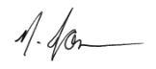

Nicky Jonsson
Director of Corporate Services

Mail or In-Person: 106-3270 Village Way, Sun Peaks, BC V0E 5N0
Email: admin@sunpeaksmunicipality.ca
Fax: 250-578-2023

